**Object Oriented Programming Project Report**

**On**

**MYNTRA**

Submitted by

Prakash Kumar Singh

Anusha Patil

SCHOOL OF COMPUTER SCIENCE & ENGINEERING

Academic year 2021-22

| 1. | Introduction | |
| --- | --- | --- |
|  | 1.1 | Overview of the problem statement |
|  | 1.2 | Features of Application  1.2.1 Registration of new user and login process.  1.2.2 Shopping  1.2.3 Placing Order |
| 2. | Design | |
|  | 2.1 | Class Diagrams |
| 3. | 2.2 Description of each class  Implementation | |
|  | 3.1 | Test Plans |
|  | 3.2 | Results |

1. **Introduction**
   1. **Overview of Problem Statement**

Let us consider the simulation of the MYNTRA app. Myntra is a major Indian fashion e-commerce company headquartered in Bengaluru. Through the Myntra app, users can order clothing items, shoes, and electronics.

* The items the customer would like to buy are first added to the cart in the Myntra app.
* A virtual bill and the total amount are generated in the cart.

Items include shoes, clothing items, and electronics from which the customer can choose.

* The shoes and clothing items are for men and women.

Customer can pay the amount through the payment methods provided by the Myntra app i.e., debit card, credit card, and cash on delivery (COD).

* Discount coupons can be applied in the cart as well.

The debit card debits the amount from the customer’s bank account.

* Credit card also deducts the amount from the same customer’s bank account but in installments (EMI), with a 3-month,6-month and 12-month plan. COD just generates the bill.
  1. **Features of Application**

1. **Registration of new User and login process**

If the user has Myntra account then user need to sign up

with appropriate user ID and password.

If the user is new to Myntra then the user need to provide few details like user ID, Password, Username, Address, Email.

1. **Shopping**

In this feature, user can purchase any product as per category (men, women ,kids, electronic) .The user has to enter the item ID to select any product. The selected items moved to shopping carts and user can view the cart.

1. **Placing Order**

After selecting items user can place order directly from shopping cart and can select mode of payment (Credit/Debit,EMI,COD).

**2.Design**

**2.1 Class diagram**

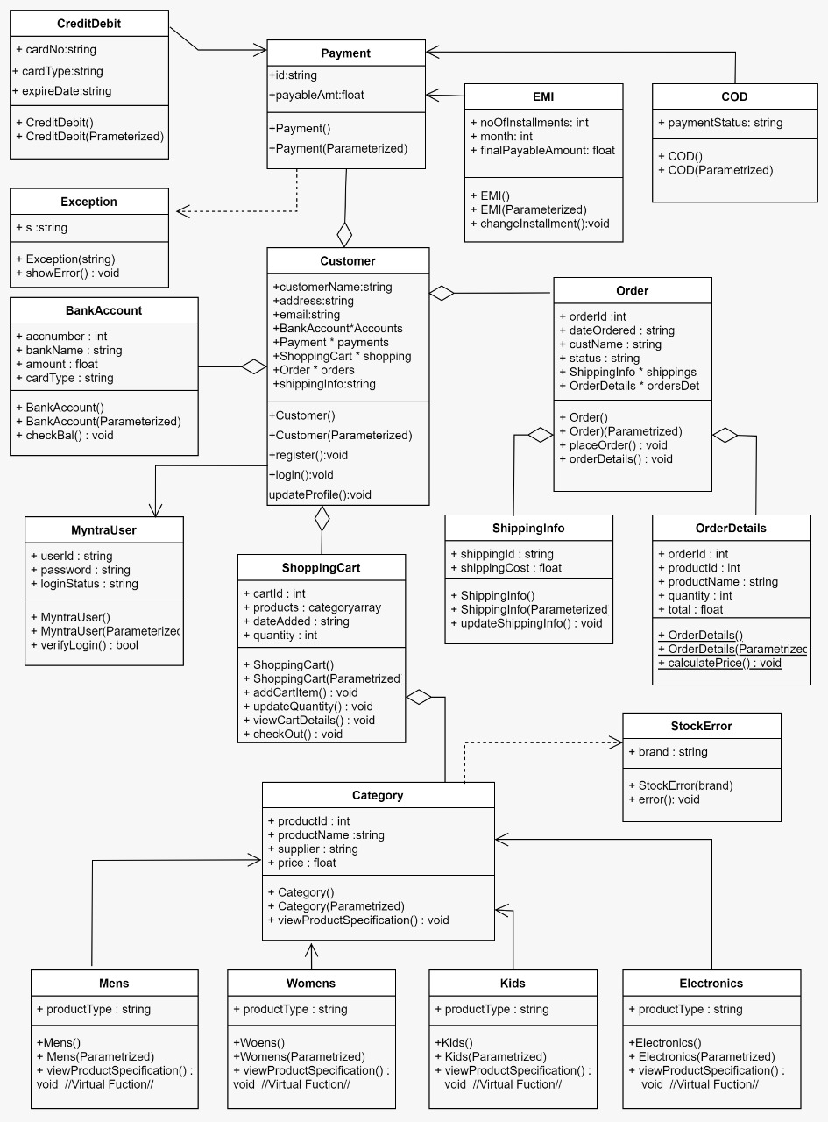

**2.2 Description of each class**

1.Customer

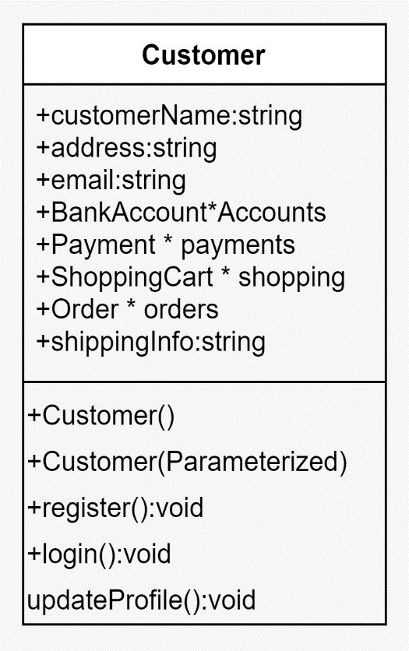

* The class Customer is the base class which consists of customername, address, email ,shippinginfo .
* Functions= To login , to create new Myntra account and user can update their profile.

2. Myntra user

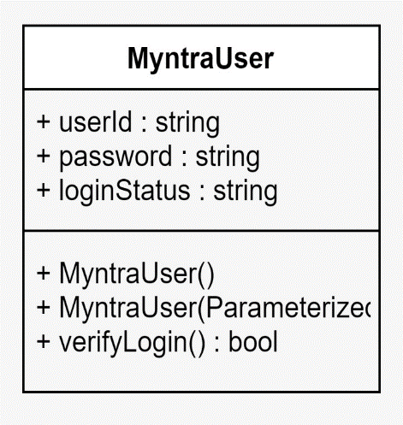

* Relationship=Customer is MyntraUser
* If the user has his/her account in the Myntra, then they can directly login by entering id and password.

3.Order

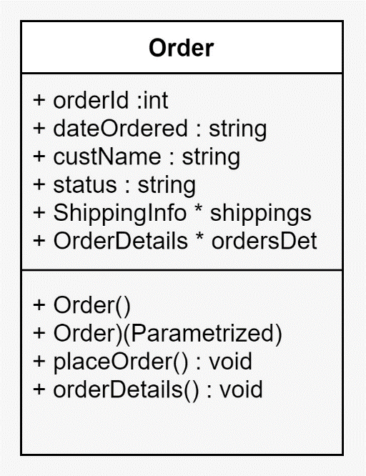

* Relationship = Customer has Order.
* Function = places the order.

4. Order Details

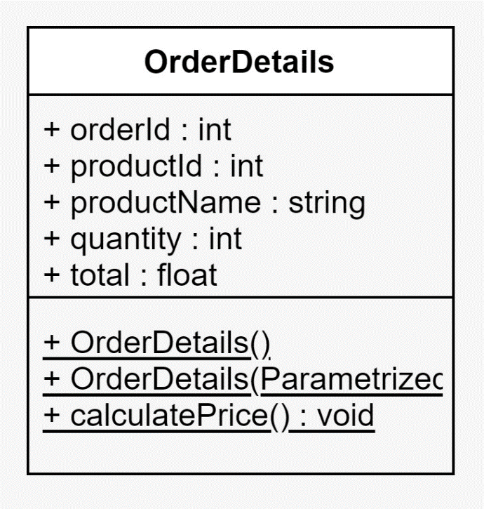

* Relationship =Order has OrderDetails.
* This class contains ordered,productid,productname,quantity and total.
* Functions= Calculates the total amount.

5. ShippingInfo

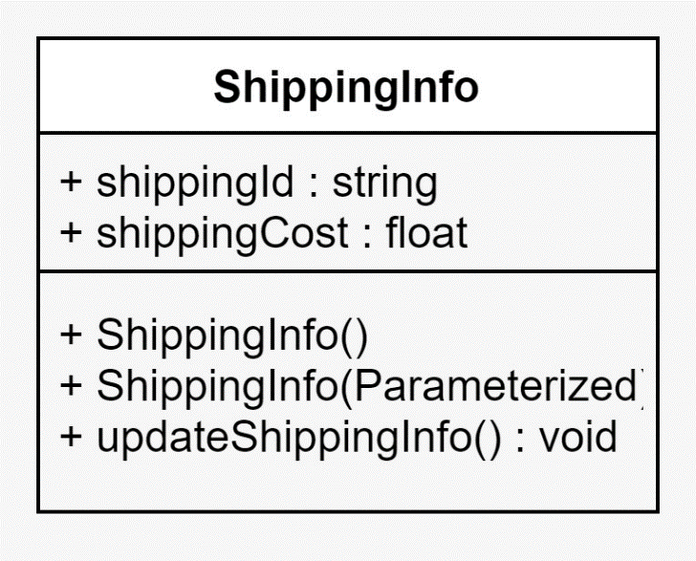

* Relationship = Order has ShippingInfo.
* Function= Prints shipping info of particular Order.

6. Payment

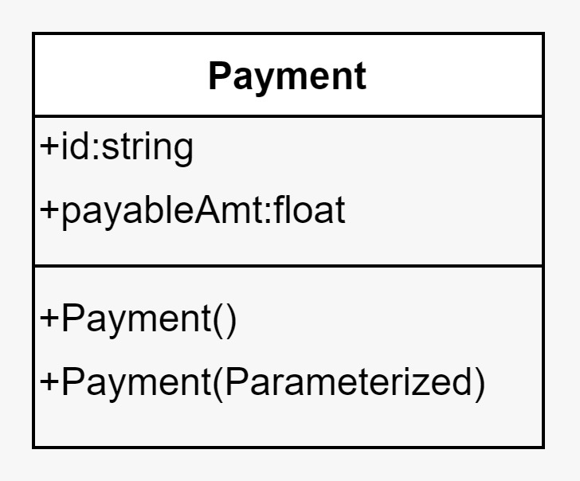

* Relationship= Customer has payment.

6.1 CreditDebit:

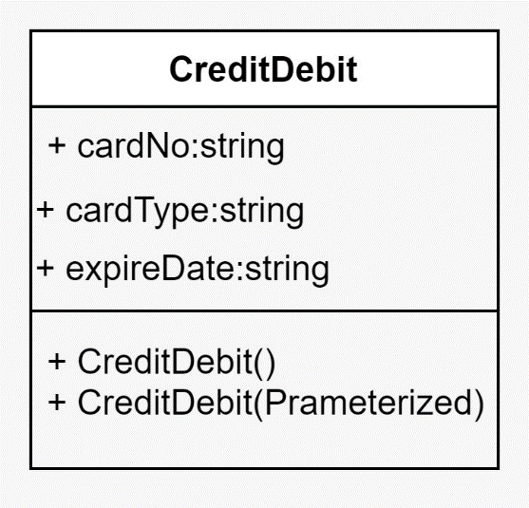

* Relationship = CreditDebit is Payment.
* The user can pay bill from Credit or from debit card.
* The payable amount will be deducted and their bank balance will be updated automatically.

6.2 EMI:

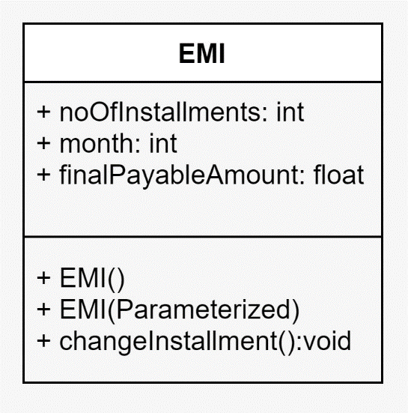

* Relationship= EMI is Payment.
* Installment with a 3-month,6-month and 12-month plan.

6.3 COD:

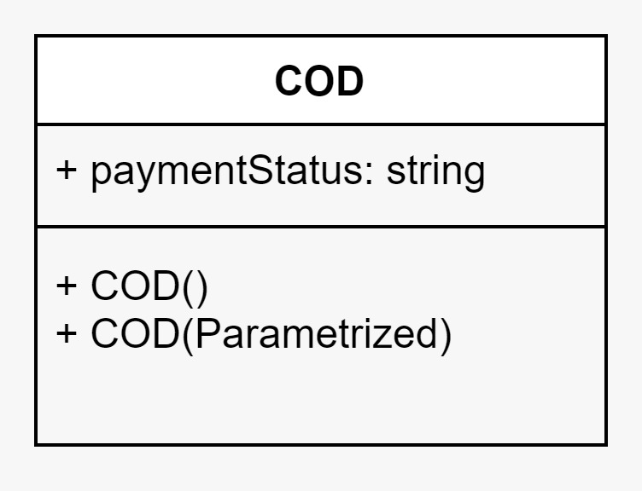

* Relationship=COD is Payment.
* COD(cash on delivery) directly generates bill.

7. BankAccount

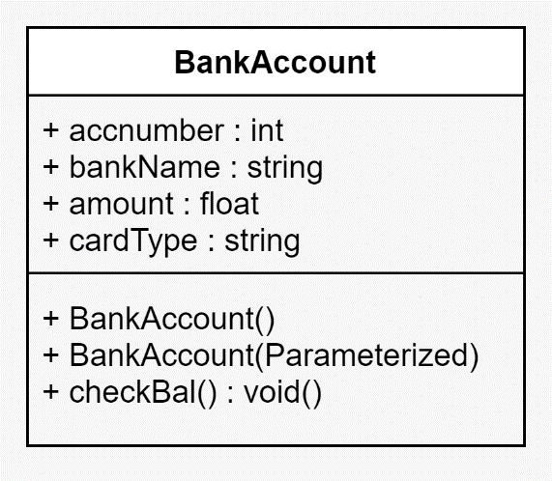

* Relationship = Customer has BankAccount.
* Function = check the balance whether the customer can pay the total bill.

7.1 exceptional class:

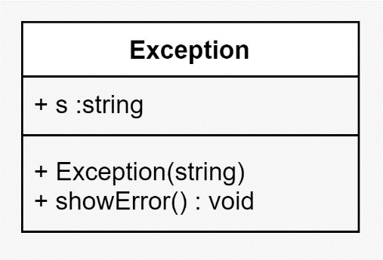

* This is exceptional class.
* Check whether the customer bank balance is sufficient to pay the total bill , if not it will throw the exception .

8. ShoppingCart

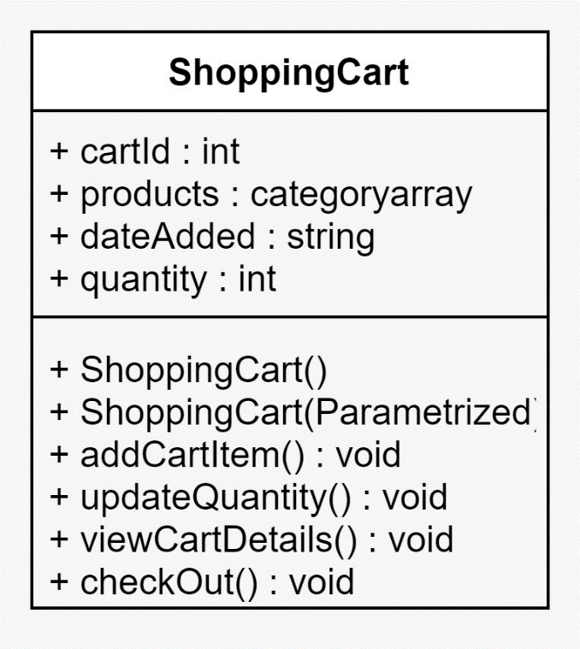

* Relationship= Customer has ShoppingCart.
* Function = User can add items, view cart.

9. Category

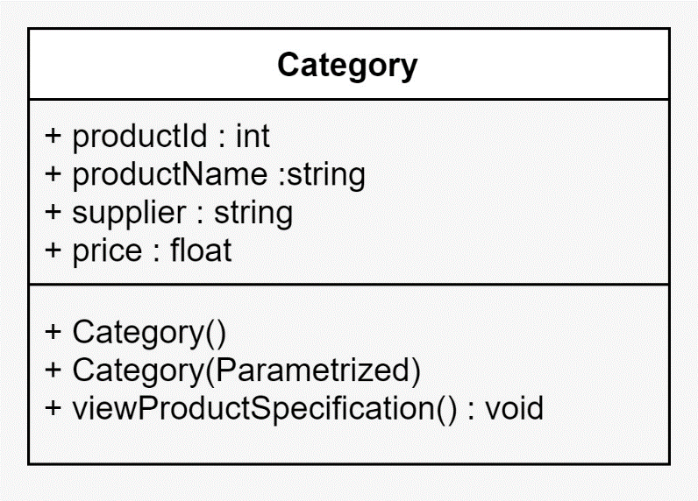

* Relationship = ShoppingCart has Category.
* Function = View Products and user can select the items that he/she wishes to buy.

9.1 Mens:

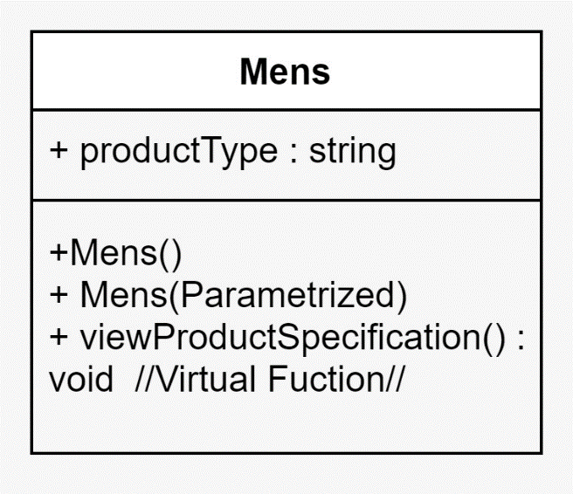

* Relationship = Mens is Category.
* Function = View products of category Mens.

9.2 Womens:

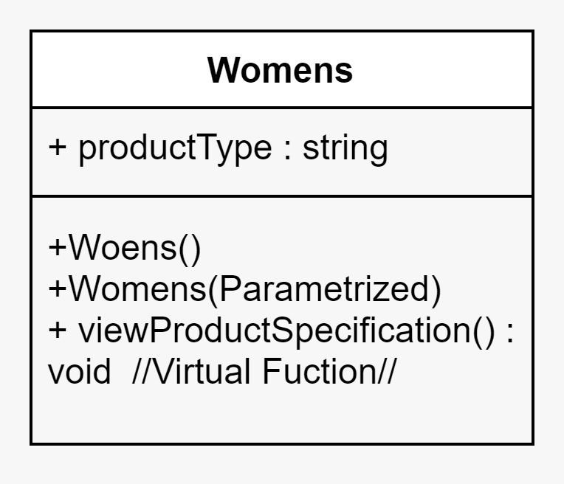

* Relationship = womens is Category.
* Function = View products of category womens.

9.3 Kids:

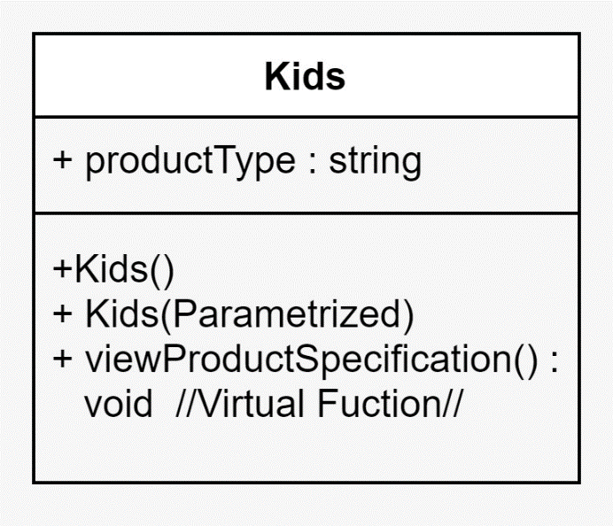

* Relationship = Kids is Category.
* Function = View products of category Kids.

9.4 Electronics:

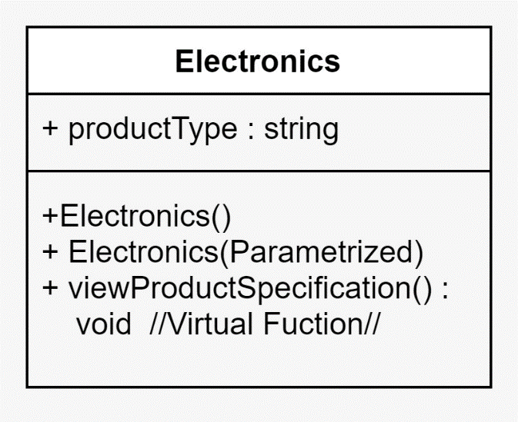

* Relationship = Electronics is Category.
* Function = View products of category Electronics.

9.5 StockError:

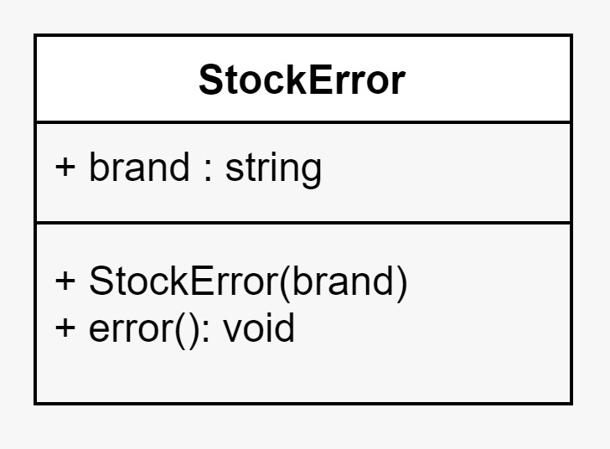

* This is a exception class.
* Function = Check whether the Stock of product are available , if not then it will throw the exception.

**3. UNIT TEST PLAN AND IMPLEMENTATION**

**1. Creating new user :** It takes the input of the user such as

user ID, Password, Username, Address, Email.

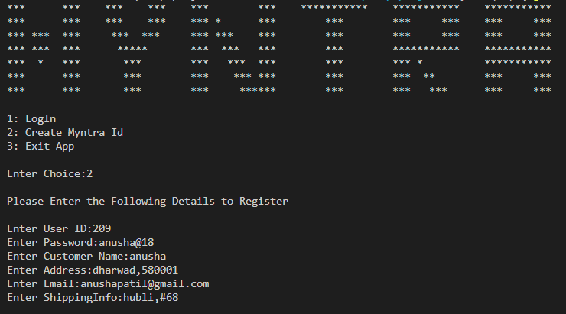

The account have been created and the user can directly login.

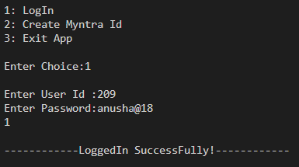

1. **Selecting Items:** In this we are displaying the category (men , women, kids ,electronic ) and asking user to select category and shop.

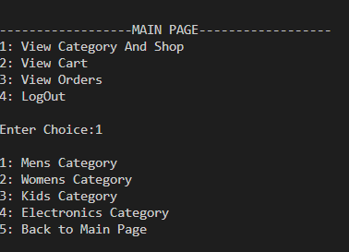

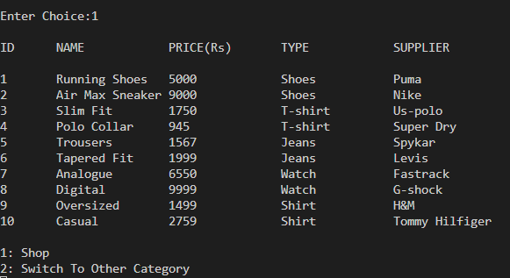

User can select item which they are willing to buy and can switch to other category.

1. **Placing Order:** The selected items are moved to shopping cart.

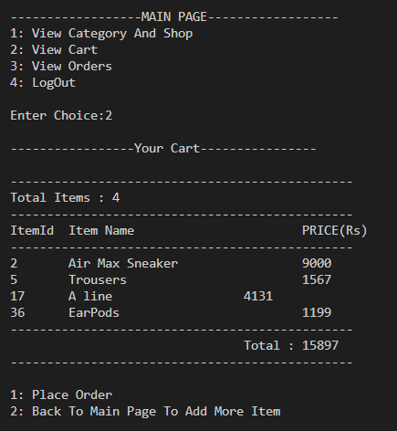

The user can place order and can select mode of payment.

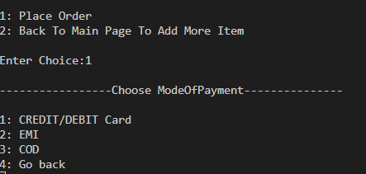

If the user choose EMI :

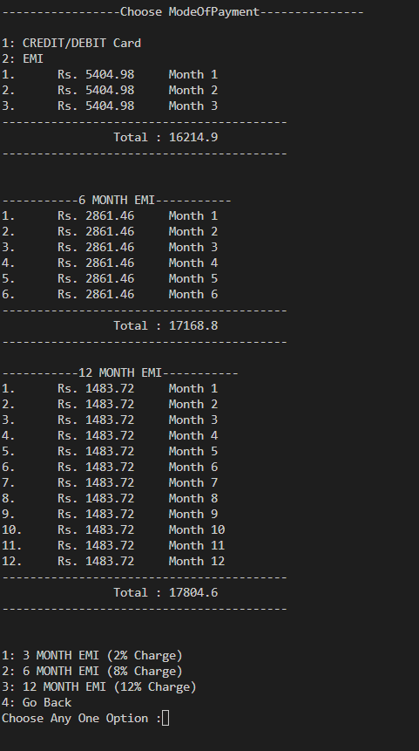

The user can view his/her order details.

1. **View order details :** User can view the order details

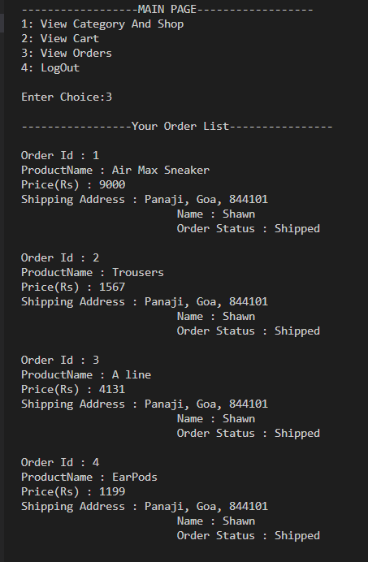

## 

## FIN